**Fanka Shundovska**

**POSTMAN Extra Homework 3/4**

In Postman:

We will use the requests from RestfullBooker to automate the requests by the following order:

-**GET**/GetBookingIds - Create test for status code 200 and store the 3rd in a row bookingId from the Array in a collection variable.

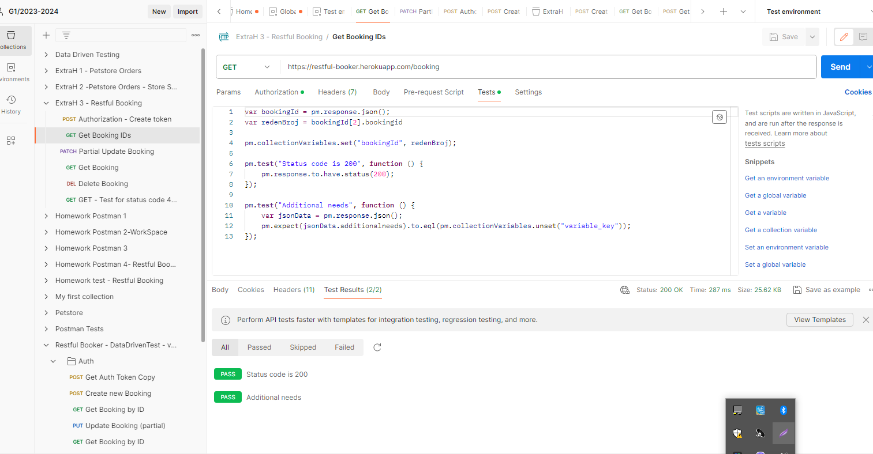

-**PATCH**/PartialUpdateBooking -  Use the same id from the previous request and in the request body insert random firstname and lastname(random from globals) and make test for status code.

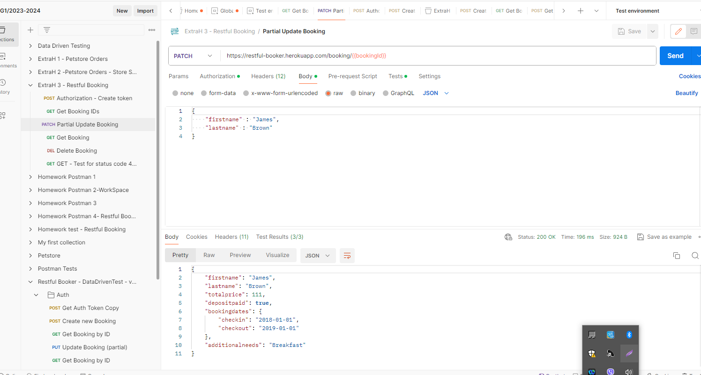

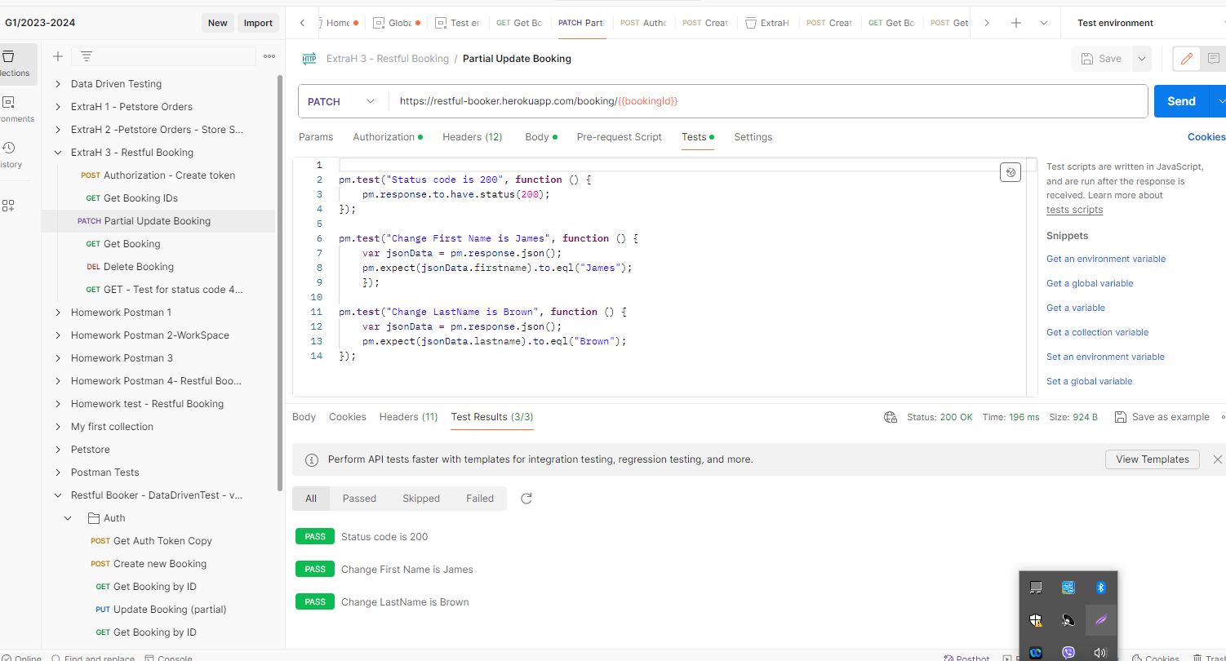

-**GET**/GetBooking - Use the same id as before, and make tests for firstName and lastname to verify that the values are updated.

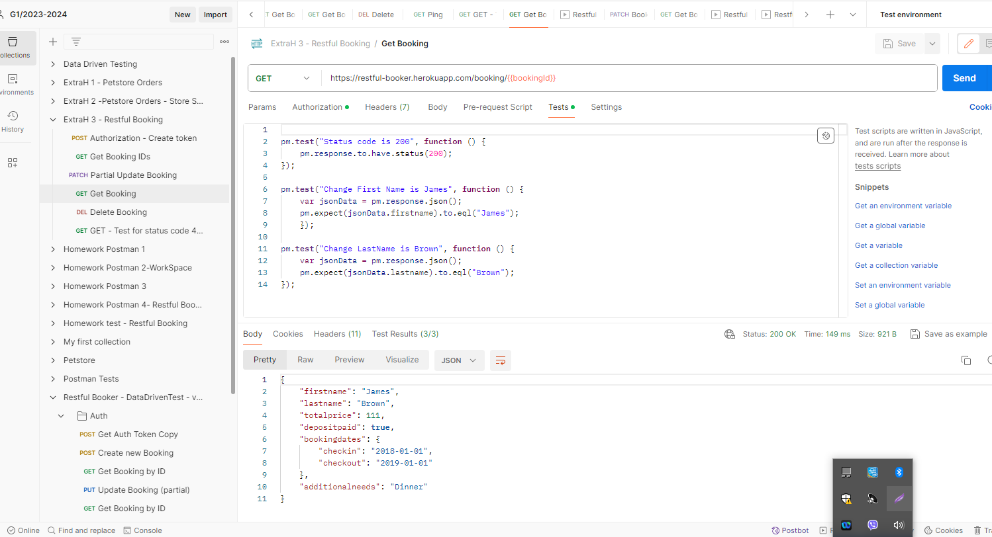

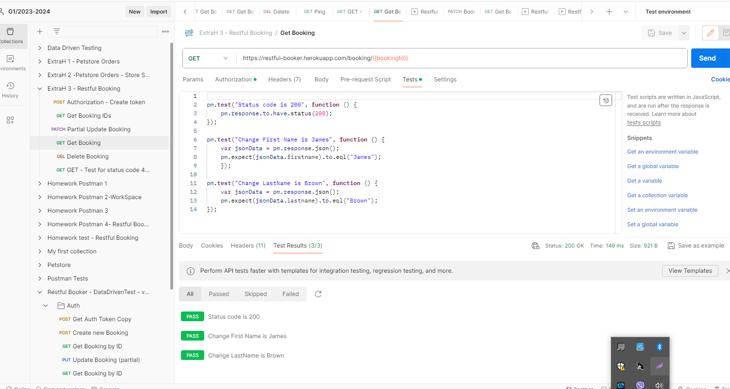

-**DELETE**/DeleteBooking - As in the previous request, use the same id and make tests that the status code is either 200 or 201.

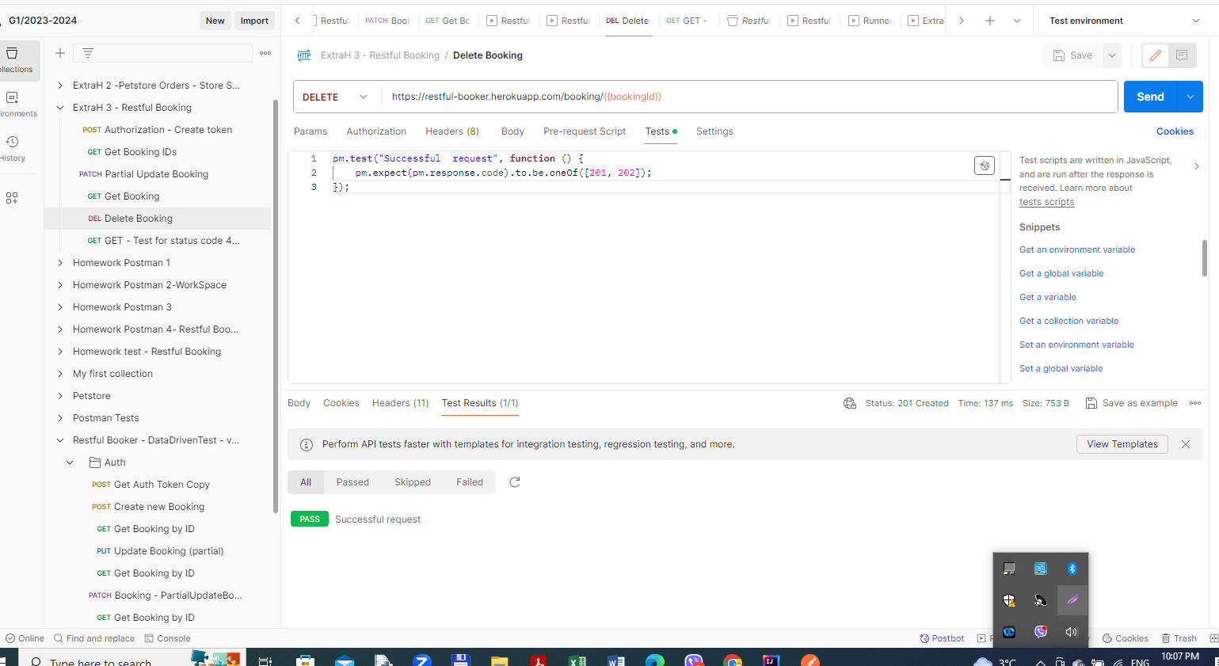

-**GET**/GetBooking - Make a test for status code 404 to ensure that the booking has been deleted.

